On the Front Lines
August 11, 2021
12:00 pm - 2:00 pm

- Welcome and Introductions
- 235 Members!
- Recent Topics
  - COVID-19
    - Medicaid plans are offering a $100 incentive to any Medicaid member who gets a vaccination dose by September 15.
    - And there are opportunities for free transportation for these members to get the vaccine. I have included the link below for more information.
    - https://covidvaxonthespot.com

  - Transitional Respite Program
    - provided by Talbert House
    - For patients that are homeless and have tested positive for Covid 19
      - Provides a safe place for the patient to quarantine
      - 3 meals a day
      - case management. The only requirements for the program are that the patient is both homeless and covid positive
      - provide transportation for the patient from the hospital to the quarantine program.
      - Michael Coppage 513-661-4620, or Whitney Wesner 513-667-2356 We are available Monday through Friday from 8am to 4pm
  - Vivitrol
    - Sunrise
    - Brightview
    - DeCoach
    - Journey Recovery
    - CRC
  - Facilities that take woman with children
    - Transitions
      - Takes Ohio residents
      - Brenda (859) 491-4435
    - First Step Home
      - Ages 12 and younger
      - Must be detoxed
      - https://www.firststephome.org/pre-screening
    - Oxford House
      - https://www.oxfordhouse.org/directory_listing.php
    - Stepping Stones-Portsmouth
      - Must be detoxed
      - 740-354-6550
    - Xenia Recovery
      - Ages 5 and under
      - https://www.recoverycentersinc.org/services/
    - House of Peace-Batavia
      - Clermont, Adams and Brown County residents only
      - 513-753-7281
    - Joshua Recovery
      - Entry into the maternity program begins with Promise To Hope at Miami Valley Hospital. To reach MVH partners directly, please call 937-208-8382 or 937-208-2481
      - http://www.joshualife.org/maternal-recovery/
  - DV
    - https://recoveryconnections.hcph.org/discussion/41/page/p1
    - House of Peace
      - 513-753-7281
    - Woman’s Crisis Center of NKY
      - Now known as Ion Center
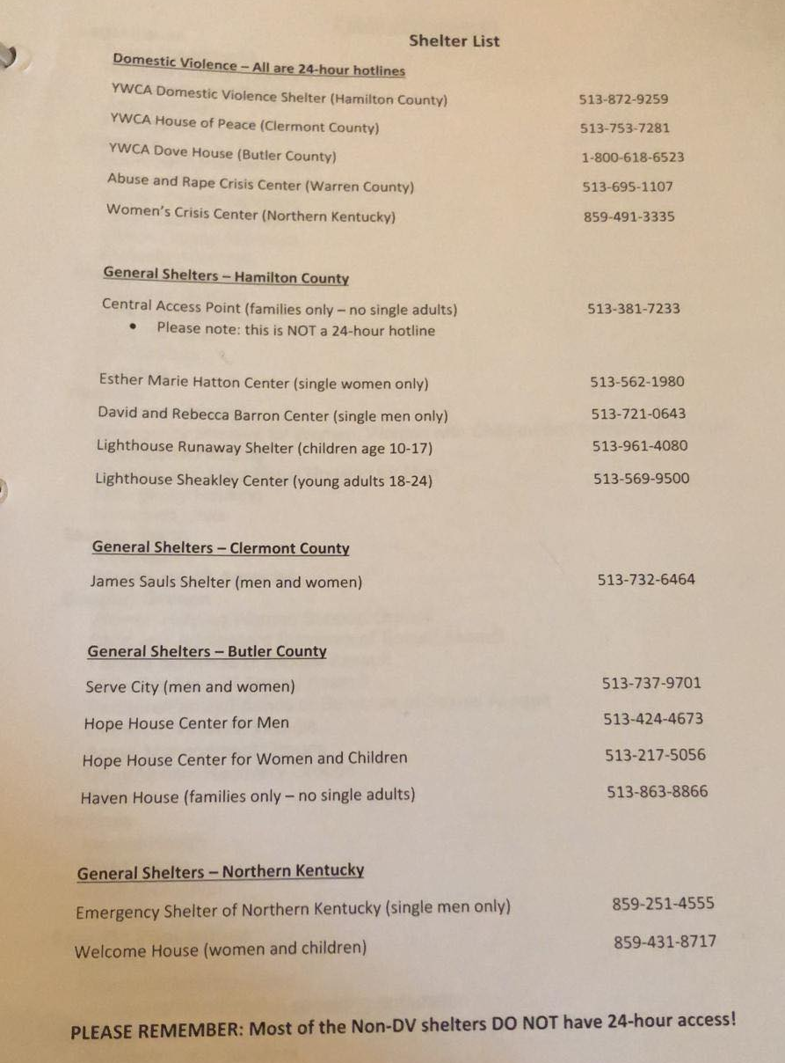

  - Dual Diagnosis Facilities
    - Woodhaven
    - Nova
    - Adams Recovery Center
    - Glenwood Behavioral (takes Medicare)
    - Sojourner
    - Beckett Springs (takes Medicare)
    - BlueRidge Vista (takes Medicare)
    - Recovery Center of Ohio
    - Georgetown Behavioral (takes Medicare)
    - CSSL (Dayton)
  - Alcohol Detox
    - Woodhaven
    - CAT
    - Access Hospital Dayton: walk-ins M-F 8a-6p
    - Cedar Oaks (out of network)
    - Mercy (ER) Clermont
    - Beckett Springs
    - Lumiere

  - Methadone Detox
    - Woodhaven (30mgs or less)
    - CAT (30mgs or less)
    - Ohio Addiction Recovery Center (40mgs or less)
    - Access Hospital (case by case basis)
    - Recovery Works-Columbus (case by case basis)
    - Cedar Oaks (60mgs)
    - CSSL (Dayton)
      - Connie Ames 937-707-2725
      - Can offer ambulatory detox (Bridge device; Speranva) Lucemyra
      - Can stay at residential facility for 2 weeks
      - Up to 120 mgs
    - Midwest Recovery Center (Toledo)
      - (35 mgs or less, case by case basis)
      - 24/7 transportation & admissions (833) 394-6853
  - Clermont Low income Housing
    - Contact James Sauls Homeless Shelter
      - 2403 Old State Rte 32, Batavia, OH 45103
      - (513) 732-6464
      - Provides vouchers
    - Bella Vista
    - College Hill
    - Beachwood Villa
    - Batavia Village
  - Medicare Facilities
    - Genisis-3-month program
    - Georgetown Behavioral-28 day
  - Recovery Housing Locator
    - https://recoveryconnections.hcph.org/discussion/42/interact-for-health-transitional-living-guide
  - Obtaining an ID
    - https://recoveryconnections.hcph.org/discussion/65/page/p1
    - Brandie Ellery, Social Services Advocate
      - 513-345-1765
      - 1125 Bank Street
      - IDs, BC, SSC, furniture & clothing vouchers
  - Presumptive Medicaid
    - HealthSource Outreach
      - 513-707-9901
      - Becky McMullen 513-707-4012
  - License Reinstatement/SR22/ Insurance Pathways
    - Alexandria Cheney
    - 513-202-6589
  - Cincinnati Health Network
    - https://recoveryconnections.hcph.org/discussion/101/cincinnati-health-network
  - Legal Aide
    - Legal Aide of Cincinnati
      - 513-241-9400
    - Pro Seniors Inc
      - 513-345-1460
  - Pet Resources
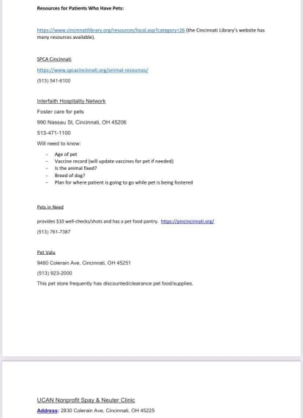

  - New Facilities Mentioned
    - Nehemiah Manufacturing
      - 2nd chance employer
      - Kim Massey
        - 513-622-9042
    - Family Prospects Program
      - https://recoveryconnections.hcph.org/discussion/97/prospect-programming
        - 740-370-2854
    - Sun Reflections
      - Faith based
      - Milford
      - 513-965-0888
      - 513-383-0262
    - Safe Harbor of Hope
      - Faith Based transitional living home
      - Clermont County
      - Intake: 513-659-3572
    - Joshua Recovery Ministries
      - BeaverCreek
      - Men’s & Woman’s Transitional Living & Maternal Programming
      - Must have 30 days in abstinence based recovery
      - Faith based
      - http://www.joshualife.org/services/
    - Recovery Defined
      - Mens & woman’s Sober Living
        - Middletown
        - Courtney 937-270-2200
    - Recovery Center of Ohio
      - Cincinnati: Monte B. 513-667-3654
      - Dayton: Diana Pearson 937-938-8357
      - TAKES COUPLES!
    - New SSP Van
      - https://www.facebook.com/hc.xchange/posts/830411867587648

    - Potter House

Community Linking Stations | Weekly Schedule
_____________________________________________________________________________________________

Tuesdays  East Price Hill |  | Weightless Anchor  1 p.m. to 4 p.m.  962 Mansion Ave  Cincinnati, OH 45205  - Harm Reduction resources & supplies  - Linkage to treatment and recovery services  - Free HIV & Hep C testing through UC Health  **serving only Weightless Anchor clients
Wednesdays  East Price Hill |  | BLOC Church  11 a.m. to 2 p.m.  931 McPherson Ave  Cincinnati, OH 45205  - Linkage to treatment and recovery services  - Connections to social services  - Peer support connections
Thursdays  Lower Price Hill |  | Community Matters  12 p.m. to 2 p.m.  2104 St. Michaels St  Cincinnati, OH 45204  - Harm Reduction resources & supplies  - Linkage to treatment and recovery services  - Connections to social services  - Peer support connections
Additional Resources:
Project Contact: Hannah Schilling (513) 999-3866
The Exchange Project Weekly Schedule-text Location to #22999
Narcan Distribution Service – text Narcan to #22999
  - Job Postings
    - Freedom Recovery
      - LCDC II
      - Dayton Office
      - Brandy.Gleason@freedomrecovery.us
    - Potter House Recovery
      - Full time counselor CDCA, LCDC II or III
      - Contact Check at 513-435-0379
    - Recovery Center
      - Live in House Managers
      - Must be in recovery at least 9-12 months
      - Cincinnati & Dayton
      - Free room & board, utilities & paid $880 biweekly
  - Events
    - Ohio PRS Conference
      - August 24th & 25th 10-2:30pm
      - https://web.cvent.com/event/e050a5fe-5eab-4334-bbdd-7822c3a537f8/summary?environment=P2
    - Easterseals Honor Ride to support veterans
      - https://p2p.onecause.com/eastersealshonorride?fbclid=IwAR27SjEspFvK0_YZ6KieL5qdGsisKnsOe_NWPnBNvhpybGK8er5hkD5ZINM
    - One Stop Resource Center
      - https://www.hamiltoncountyohio.gov/government/departments/reentry/one_stop_resource_center
    - Addiction Response Coalition Overdose Awareness Event
      - 8/29/21 11:00am-1:00pm
      - Fountain Square
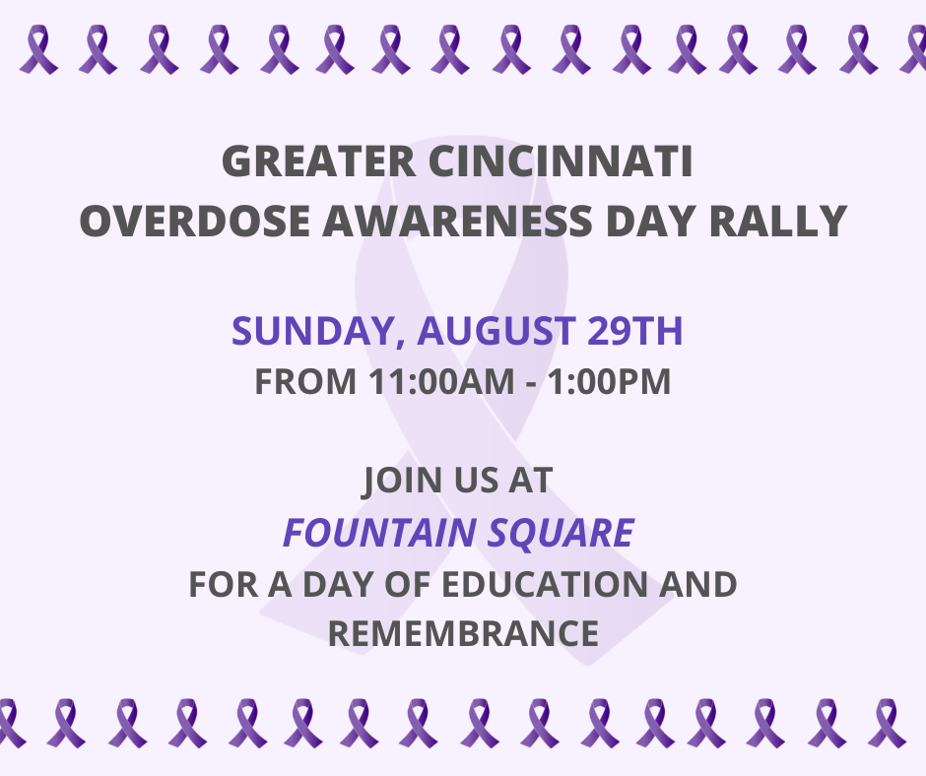
    - Addiction Services Council Overdose Awareness Event
      - 8/31/21 4:30pm-7:30pm
      - 2828 Vernon Place
      - https://www.facebook.com/events/526292138688745/?post_id=531333861517906&acontext=%7B%22source%22%3A%2229%22%2C%22ref_notif_type%22%3A%22admin_plan_mall_activity%22%2C%22action_history%22%3A%22null%22%7D&notif_id=1625601458581406&notif_t=admin_plan_mall_activity&ref=notif
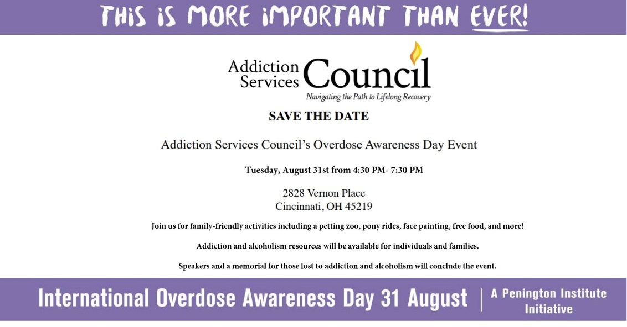

    - The FOA Rally 4 Recovery
      - August 29, 2021 2 pm to 6 pm
      - Dayton Courthouse Square
      - https://www.facebook.com/events/331110331923823/?post_id=349207743447415&acontext=%7B%22source%22%3A%2229%22%2C%22ref_notif_type%22%3A%22admin_plan_mall_activity%22%2C%22action_history%22%3A%22null%22%7D&notif_id=1625674480789724&notif_t=admin_plan_mall_activity&ref=notif
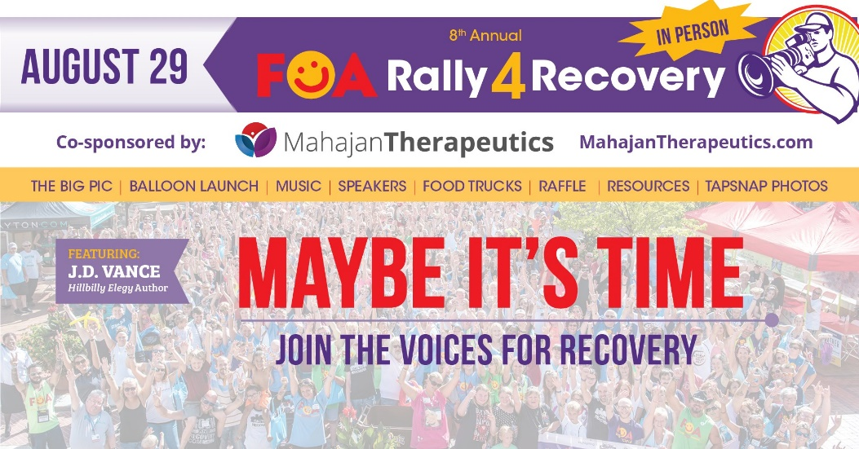
    - New Foundations Fundraiser

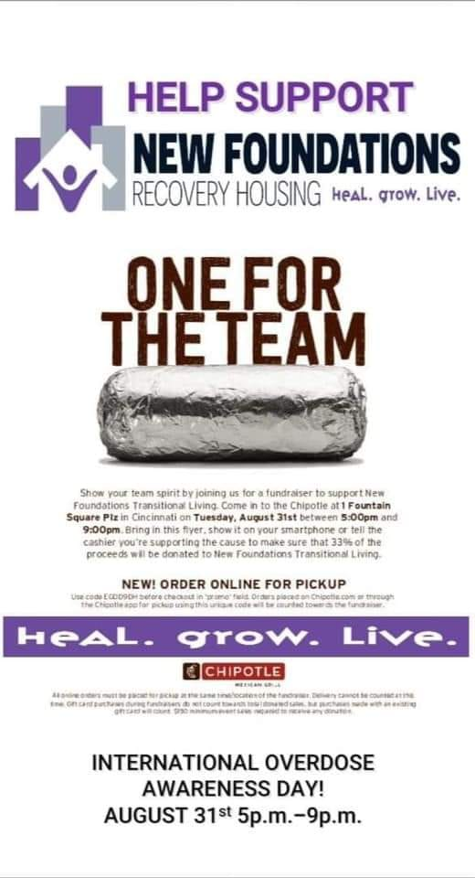
- Trainings
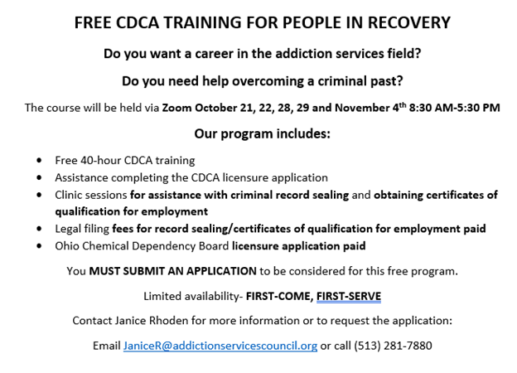
- Key Note
    - LIT
      - Stephanie Neely
      - Tyler Schmidt
    - From Fatherless to Fearless
      - Candice Crear
- Currents barriers/concerns
- Future Meeting Presenters/Topics
- Questions/Discussion
  - https://recoveryconnections.hcph.org/discussions
    - Forum for recovery professionals to share resources and network
- Upcoming Meetings
  - September 2, 2021 12:00pm

