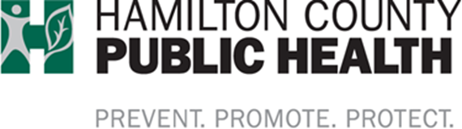

Community Linking Stations | Weekly Schedule
Harm Reduction – practical strategies and tools to promote safety, health, and wellness for individuals and the community

__________________________________________________________________________________________________________

Tuesdays  East Price Hill |  | Weightless Anchor  1 p.m. to 4 p.m.  962 Mansion Ave  Cincinnati, OH 45205  - Harm Reduction resources & supplies  - Linkage to treatment and recovery services  - Free HIV & Hep C testing through UC Health  **serving only Weightless Anchor clients
Wednesdays  East Price Hill |  | Revive Church  11 a.m. to 2 p.m.  931 McPherson Ave  Cincinnati, OH 45205  - Linkage to treatment and recovery services  - Connections to social services  - Peer support connections
Thursdays  Lower Price Hill |  | Community Matters  12 p.m. to 2 p.m.  2104 St. Michaels St  Cincinnati, OH 45204  - Harm Reduction resources & supplies  - Linkage to treatment and recovery services  - Connections to social services  - Peer support connections
Additional Resources:
The Exchange Project Weekly Schedule-text Location to #22999
Narcan Distribution Service – text Narcan to #22999

The Exchange Project | Weekly Schedule
Harm Reduction – practical strategies and tools to promote safety, health, and wellness for individuals and the community

__________________________________________________________________________________________________________

Mondays  Over-the-Rhine |  | Over-the-Rhine  10 a.m. to 1 p.m  106 W. McMicken Ave  Cincinnati, OH 45202
Tuesdays  Middletown |  | Middletown  10 a.m. to 1 p.m.  1300 Reynolds Ave.  Middletown, OH 45044
Thursdays  Corryville  & Northside |  | Coryville  1 to 4 p.m.  Hamilton County Public Health  250 William Howard Taft (Rear)  Cincinnati, OH 45219  Northside | Caracole  5 to 7:30 p.m.  Caracole  4138 Hamilton Avenue  Cincinnati, OH 45223
Fridays  Western Hills |  | Western Hills  1 to 4 p.m.  Talbert House (Rear)  4968 Glenway Avenue  Cincinnati, OH 45238

Questions:
Call/text 513-316-7725
Email: exchangeproject@hamilton-co.org
Follow us on Facebook – The Exchange Project

