On the Front Lines
July 8, 2021
12:30 pm - 2:00 pm

- Welcome and Introductions
- 212 Members!
- Recent Topics
  - Maslows Army Day Center has closed indefinitely
  - CAT no longer charging admission fee
    - Intake line- 513-381-6672
  - Lycamyra
    - 1st non opioid treatment for managing opioid withdrawal symptoms
    - taken orally 4 times daily during the peak time of withdrawal symptoms, generally the first 5 to 7 days following last opioid use at 5-to-6-hour intervals for up to 14 days
    - https://www.pharmacytimes.com/view/how-lucemrya-reduces-opioid-withdrawal-symptoms
  - Bridge device; Speranva
    - Non invasive drug free intervention device that uses deep neural stimulation to the brain through easily-accessible branches on the ear.
    - https://speranzatherapeutics.com/st-genesis/

  - reSET
    - 24/7 remotly accessible tool prescribed to patients to increase retention in recovery process by using evidence-based approaches, like cognitive behavioral therapy, fluency training, and contingency management.
    - https://www.resetforrecovery.com/
  - Dual Diagnosis Facilities
    - Woodhaven
    - Nova
    - Adams Recovery Center
    - Glenwood Behavioral (takes Medicare)
    - Sojourner
    - Beckett Springs
    - BlueRidge Vista
    - Recovery Center of Ohio
    - Georgetown Behavioral (takes Medicare)
    - CSSL (Dayton)
  - Methadone Detox
    - Woodhaven (30mgs or less)
    - CAT (30mgs or less)
    - Ohio Addiction Recovery Center (40mgs or less)
    - Access Hospital (case by case basis)
    - Cedar Oaks (60mgs)
    - CSSL (Dayton)
      - Connie Ames 937-707-2725
      - Can offer ambulatory detox (Bridge device; Speranva) Lucemyra
      - Can stay at residential facility for 2 weeks
      - Up to 120 mgs
    - Midwest Recovery Center (Toledo)
      - (35 mgs or less, case by case basis)
      - 24/7 transportation & admissions (833) 394-6853

  - Facilities that take woman with children
    - First Step Home
      - Ages 12 and younger
      - Must be detoxed
      - https://www.firststephome.org/pre-screening
    - Oxford House
      - https://www.oxfordhouse.org/directory_listing.php
    - Stepping Stones-Portsmouth
      - Must be detoxed
    - Xenia Recovery
      - Ages 5 and under
      - https://www.recoverycentersinc.org/services/
    - House of Peace-Batavia
      - Clermont, Adams and Brown County residents only
      - 513-753-7281
    - Joshua Recovery
      - Entry into the maternity program begins with Promise To Hope at Miami Valley Hospital. To reach MVH partners directly, please call 937-208-8382 or 937-208-2481
      - http://www.joshualife.org/maternal-recovery/
  - New Foundations Partner Referral
    - Will waive $100 intake fee with partner referral form
    - $20 will be owed at time of intake to supplement cost of drug screening
  - Medical Detox Facilities with KY Medicaid
    - Sun Behavioral
    - Transitions
    - Recovery Works
  - Treatment/Transitional Living for SO
    - VOA
    - Wilson House
    - Salvation Army DOES NOT
  - Utility Assistance
    - https://recoveryconnections.hcph.org/discussion/92/financial-assistance
  - Recovery Housing Locator
    - https://recoveryconnections.hcph.org/discussion/42/interact-for-health-transitional-living-guide
  - Obtaining an ID
    - https://recoveryconnections.hcph.org/discussion/65/page/p1
  - Bus Passes
    - Forms sent out through invite
  - New Facilities Mentioned
    - Safe Harbor of Hope
      - Faith Based transitional living home
      - Clermont County
      - Intake: 513-659-3572
    - Joshua Recovery Ministries
      - BeaverCreek
      - Men’s & Woman’s Transitional Living & Maternal Programming
      - Must have 30 days in abstinence based recovery
      - Faith based
      - http://www.joshualife.org/services/
    - Cedar Oaks
      - Inpatient detox (6 beds) & residential (20 beds) in Lebanon
      - Accepts expectant mothers in all trimesters
      - Private Insurance Only
      - Transportation provided
      - Hope Line (513) 932-4673
      - Jennie McConnaughey (513) 917-5639

    - Lynx EMS
      - Owned by Blue Ridge Vista
      - Specializes in patients with psychosis
      - Takes most insurance if patient qualifies for ambulance transport (under 72 hour hold/probated)
      - Runs until midnight
      - Can be used independently
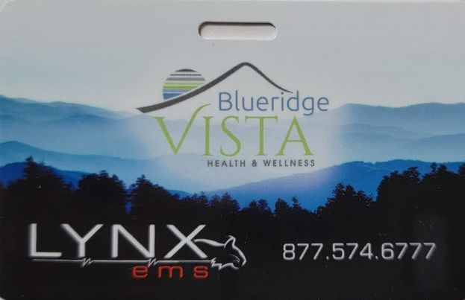
    - ARC
      - Residential, PHP, IOP, MAT
      - Provides Transportation
      - All KY Medicaid & CareSource of Ohio
      - William Pfefferman 859-444-2729
    - S.T.R (Short Term Refuge)
      - Up to 3 day refuge for MEN transitioning into treatment
      - 4 beds
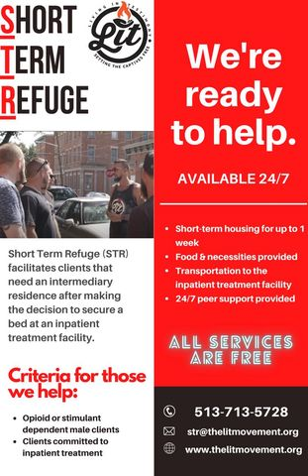
    - Pax House
      - Men’s Transitional Living
      - New House manager: Tony Stanfill
      - 513-446-4246
    - Ohio State University Wexner Medical Center Talbot Hall & Harding Hospital
      - https://wexnermedical.osu.edu/mental-behavioral/addiction-drugs?fbclid=IwAR0L7f9W-xq5JgSJCwsbJ_QuKQcKHdjUHFufeDRD1UWLWASmCBx7LXB4Hsw
      - 614-257-3760/ 614-293-4326
      - Withdrawal management, PHP, IOP, OP, MAT
      - Bridge Device-alternative to inpatient w/d management and provides an opportunity for OP w/d without medication
      - Uses reset & reset-O
    - Woman in Distress
      - 24 Hour Crisis Hotline (954)761-1133
      - Emergency shelter, counseling, resources
      - https://www.womenindistress.org/we-can-help/emergency-shelter/
    - One City for Recovery
      - Community street outreach & collaborations with community organizations
      - Non-bias & client driven, assisting individuals to get connected to services
      - Offers transportation for individuals awaiting appointment with treatment programming or sober living
      - Narcan distribution & service coordination to inmate’s pre-release
      - Offers up to $100 in financial support for individuals seeking recovery housing
      - 2 Hamilton County Liaisons
        - Alexandria Cheney 513-330-2903
        - Tyler Schmidt 513-591-8829
    - Freedom Hall
      - Pike County
      - Faith-based inpatient program
      - Housing up to 30 men and 17 women
      - 9-month program
      - No insurance necessary
      - Beth Bullock 513-212-8176
    - Safe Families
      - Respite Care
      - Provides host family for individuals who do not have family or community support while seeking services
      - https://safe-families.org/location/
      - 513-279-2211 Office
      - Hours M-F 9-4
    - Tamars Center
      - Day Center addressing woman’s most urgent needs
      - In Center 8:30am-12pm M-F
      - https://www.franciscanministriesinc.org/tamar-s-center.html
      - Estelle McNair, Director
      - 513-780-0622
    - CSSL (Dayton)
      - Previously called Clean Slate sober living
      - Can offer ambulatory detox (Bridge device, Speranva) Lucemyra
      - Abstinence based program in Dayton
      - Base program 16 week, up to 6 months aftercare
      - Partners with nonprofit for housing only for clients; staffed
    - Center for Mindful Healing
      - Middletown
      - PHP, IOP, OP, Recovery Housing
      - https://themindfulhealingcenter.com/
    - Midwest Recovery Center
      - 5 locations in Toledo area
      - Mens & Womans-450 beds total
      - Detox (17 female, 24 male), Residential (37 male, 21 female), PHP with residential housing if needed, IOP, MAT
      - Will accept couples in inpatient care
      - 24/7 transportation & admissions (833) 394-6853
      - Medicaid & private insurance
      - https://www.midwestrecoverycenter.com/addiction-treatment-center-programs-oh/
  - Job Postings
    - Nova, Peer Support Specialist
      - https://www.indeed.com/jobs?q=CDCA&l=Cincinnati%2C%20OH&radius=50&start=10&advn=4970554637304872&vjk=ca72f9fcd361665c
    - DeCoach
    - KAV
    - Woodhaven
    - Brightview
    - Recovery Center of Ohio
      - https://www.indeed.com/jobs?q=peer%20support%20specialist&l=Cincinnati%2C%20OH&radius=50&advn=8547624778657687&vjk=7d428e65ba576f63
    - ASC-NKY Counselor
      - https://www.indeed.com/viewjob?jk=54174c31bb6061c8&advn=7034444874179849&adid=371465766&ad=-6NYlbfkN0DWVk5qpT8b_Yn4gVQrUxPtdxg_mgcD19pU99xTHA3vvLbBRN5wzw0JkRymxUhxbAvZ7RDEtPWwZ_5ixXo36RRMlSoJG5leMR-nknMfefehfUG8pAa2nztnt7Xhn_uJmt-Bb_t73rQ_32UHAa35DL3qCxcYNYZ_6xpn1KX5HhUu7nhKHZ7hkpMmVE8ht5K7jsCtOhsKH200FhlGoG1VVya1plfyigUB8HclrFMdkaTpoq2I8b5sg2CWLCcH09qdrtXLAkqQbGyT36NiR5fPBDOBo_hae787Mq1eKB9XM1yfMZuJrWaChUjdnLvzfvlSVSwLpPIuGcPsP_EIBPV5lTexMl7t-3-yk70nbCtj2i9WHuOvVN96VBkjlqngaF7eSrlkzggBv2JDaO60oJvBN-G7&from=hp&from=mobRdr&tk=1f9hhfrbku4l3803&fbclid=IwAR0xcsG9gzH8lSNOG4EiQDm74QECse8KteD5HHcoVfHDFXdPEbFMlpds1_I&utm_source=%2Fm%2F&utm_medium=redir&utm_campaign=dt

  - Events
    - On the Road to Recovery
      - August 3rd 3:30pm-7:30pm
      - Talbert House ADAPT for Men & Women (3009 Burnet Ave)
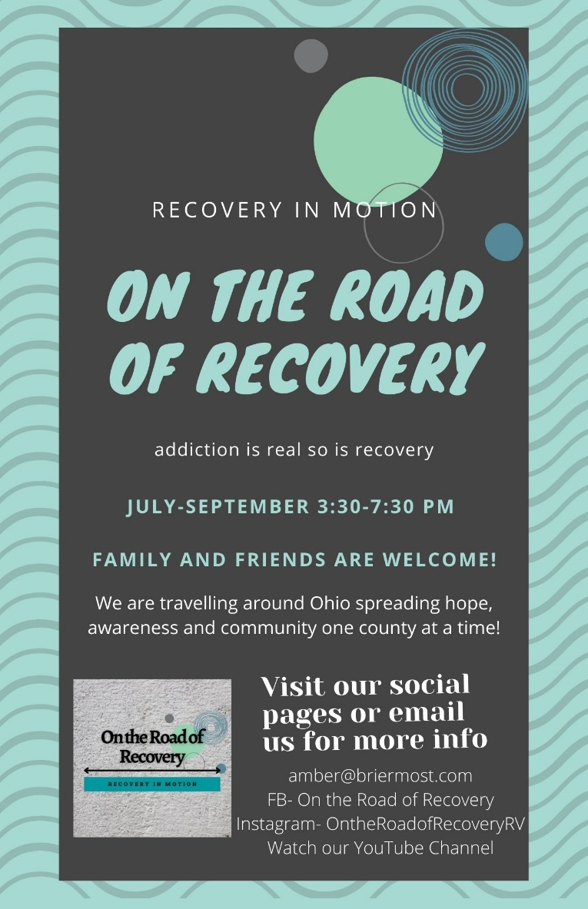

    - Addiction Response Coalition Overdose Awareness Event
      - 8/29/21 11:00am-1:00pm
      - Fountain Square
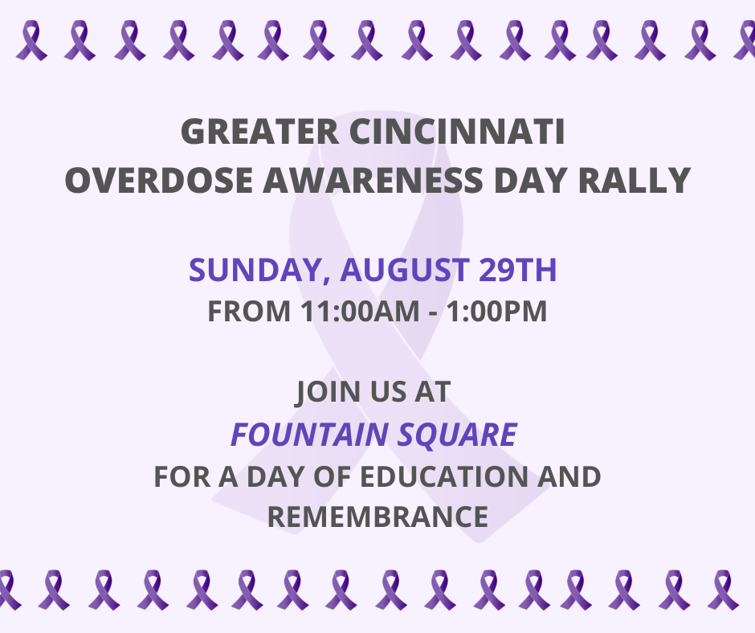

    - Addiction Services Council Overdose Awareness Event
      - 8/31/21 4:30pm-7:30pm
      - 2828 Vernon Place
      - https://www.facebook.com/events/526292138688745/?post_id=531333861517906&acontext=%7B%22source%22%3A%2229%22%2C%22ref_notif_type%22%3A%22admin_plan_mall_activity%22%2C%22action_history%22%3A%22null%22%7D&notif_id=1625601458581406&notif_t=admin_plan_mall_activity&ref=notif
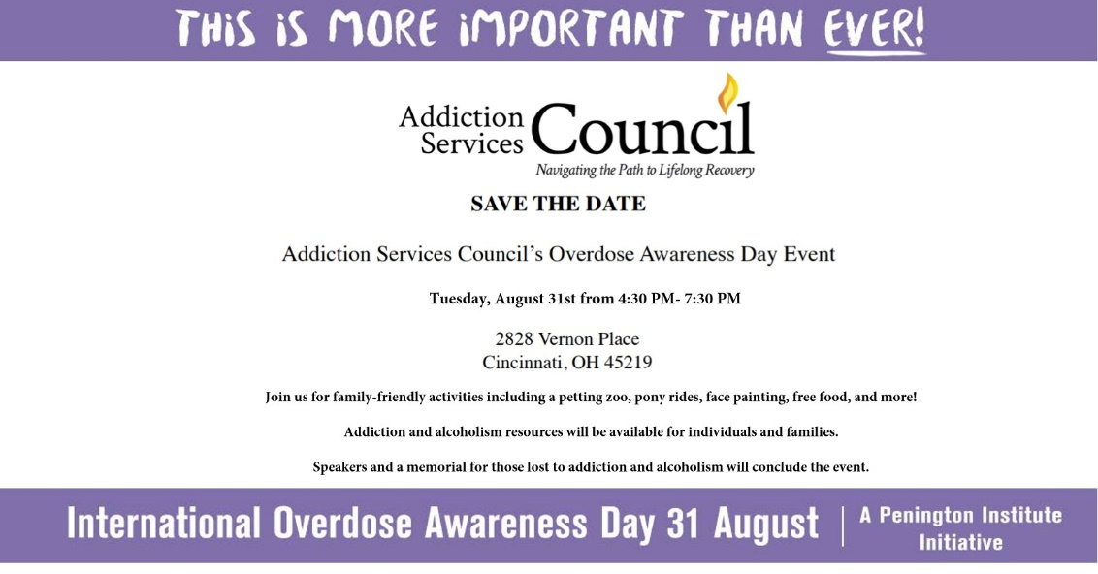

    - The FOA Rally 4 Recovery
      - August 29, 2021 2 pm to 6 pm
      - Dayton Courthouse Square
      - https://www.facebook.com/events/331110331923823/?post_id=349207743447415&acontext=%7B%22source%22%3A%2229%22%2C%22ref_notif_type%22%3A%22admin_plan_mall_activity%22%2C%22action_history%22%3A%22null%22%7D&notif_id=1625674480789724&notif_t=admin_plan_mall_activity&ref=notif
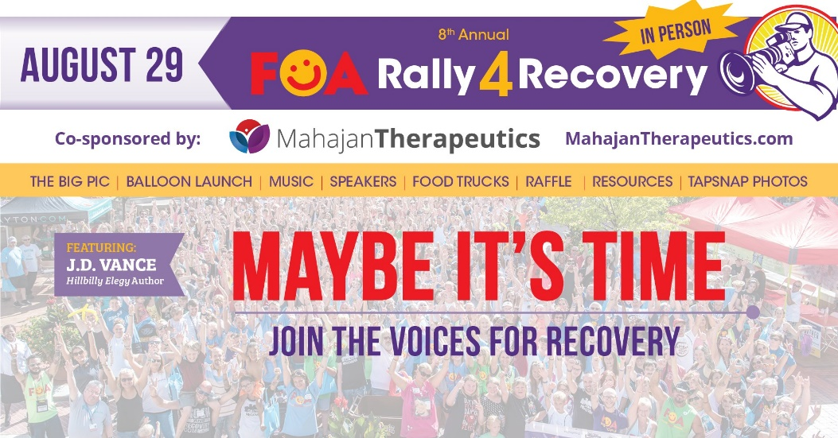

    - New Foundations
      - https://www.eventbrite.com/e/celebration-of-freedom-new-foundations-fireworks-community-gathering-tickets-157288256409?fbclid=IwAR2UWX-NdGkfFXvVBAx5fHiyPong6rByQOnT3Vt-a8U0o9zSvA_dtQketZU

    - Rose Ministry Picnic
      - July 10th 11:30am
      - 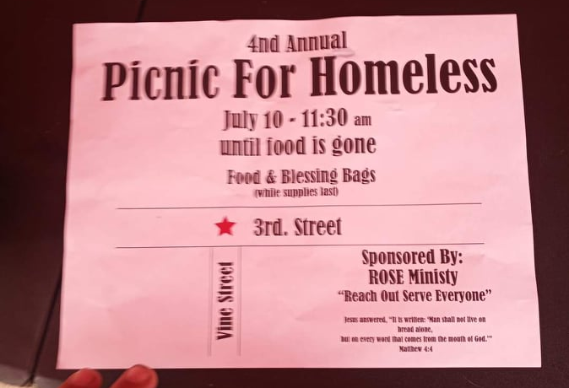
- Key Note
  - Recovery Center of Ohio
    - Caitlyn G. Nelei-Nunnemaker MS LPCC-S LICDC, Center Director
    - Monte Barnet
- Currents barriers/concerns
- Future Meeting Presenters/Topics
- Questions/Discussion
  - https://recoveryconnections.hcph.org/discussions
    - Forum for recovery professionals to share resources and network
- Upcoming Meetings
  - August 12, 2021 12:30pm

