On the Front Lines
April 8th, 2021
12:00 pm - 1:00 pm

- Welcome and Introductions

- Recent Topics

  - KY Narcan Access
    - All County Health Centers
      - https://nkyhealth.org/contact-us/locations/county-health-centers/
Syringe Service Sites:
    - Campbell County
      - Highrise Drive, which is off Churchill Drive at the intersection of North Grand Drive in Newport, Ky. from 1 to 4 p.m. on Tuesdays
    - Grant County
      - Grant County Health Center from 1 to 4 p.m. on Wednesdays
    - Campbell County
      - St. Elizabeth Healthcare, 1500 James Simpson Jr. Way, from 1 to 4 p.m. on Thursdays

  - Celebrate Recovery
    - Starting in Price Hill April 17th
      - 12pm @ Olden Totlot Park
  - Ohio Means Jobs PRC
    - https://recoveryconnections.hcph.org/discussion/73/ohio-means-jobs-prc-program
  - Woman’s Crisis Centers
    - YWCA 513-872-9259
    - Woman of Alabaster
    - Woman’s Crisis Center Covington Ky
    - Bethany House (Contact through CAP Line)
    - Heart House, Indiana
    - Dove House (Hamilton, OH)

  - Felony Friendly Companies
    - https://recoveryconnections.hcph.org/discussion/29/page/p1
  - Strategies to End Homelessness
    - https://www.strategiestoendhomelessness.org/what-we-do/shelter-and-outreach/
  - Wireless Providers
    - Assurance Wireless
      - https://www.assurancewireless.com/
    - Lifeline
      - https://standupwireless.com/lifeline/
    - FeelSafe
      - https://www.feelsafewireless.com/
    - Entouch
      - https://www.entouchwireless.com/states/ohio-lifeline-free-phone-service
  - RedBike Transportation Assistance
    - Monthly Bike Rental for Homeless
    - $5 monthly bike rental for homeless
    - Red Bike Office Tuesday& Friday 11am-4pm
    - Will need ID and also to dock every 2 hours

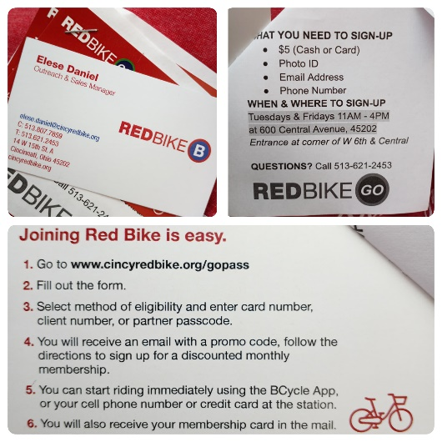
- Key Note

  - Andrea Holtman
    - Bloc Ministries

- Currents barriers/concerns

- Future Meeting Presenters/Topics
- Questions/Discussion
  - https://recoveryconnections.hcph.org/discussions
    - Forum for recovery professionals to share resources and network
- Upcoming Meetings
  - May 13, 2021 12pm

Attendees:

Chloe Striker
Care Coordinator with UC Early Intervention Program
office 513-585-8263 cell 513-704-0271

Andrea Holtman
Director of Weightless Anchor (daytime hospitality center for women on the streets of Price Hill struggling with addiction, trafficking, homelessness)
513.410.2168
andrea.holtman@onebloc.org

Kameron Meredith
UC Health Peer Recovery Specialist/Linkage Coordinator w/ Early Intervention Program
meredikn@ucmail.uc.edu (513)341-5526

Shanna Osborne
Care Coordinator in Owen County KY working for the HRSA Implementation Grant administered by NKU
Osbornes8@nku.edu 502-514-1929

Jordan Newsome
Executive Assistant with New Foundations Transitional Living
513-399-9774

Amy Parker
Community Outreach Manager, media, marketing, account mgr, specializing in court and jail services and connecting organizations to work together
aparker@nftl.org
Facebook.com/amyparkerrecovery Amy Parker The Recovery Specialist

Kelsey Richardson, Screening and Outreach Coordinator for the Law Enforcement Assisted Diversion (LEAD) Program; Kelsey.richardson@hamilton-co.org; cell: 513-497-0356

Hannah Schilling
Health Counselor Hamilton County Public Health
513-999-3866 Hannah.schilling@hamilton-co.org

Tina Fischer
Adams Recovery Center in Loveland; counselor, case manager and outreach
513-575-0968 option 1

Stephanie Neeley
Peer Support Employment Specialist, Easterseals of Greater Cincinnati
sneeley@eastersealsgc.org (513) 815-9085

Adrienne Crusey research assistant UC Addiction Sciences
email: cruseyla@ucmail.uc.edu cell: (937)-776-7318 office: (513)-585-8315

Sheryl Miles
Case Manager with the LEAD Program
Sheryl.miles@hamilton-co.org; cell: 513-497-1408

Tania Loudon
Manager of Outreach & Client Recruitment for First Step Home
513-312-1099 tania.loudon@firststephome.org

David McKee
CDCA, Peer Supporter, Addiction Services Council
dmckee@addictionservicescouncil.org 513-535-1639

Mikella Chrisman | New Foundations Recovery Housing | mchrisman@nftl.org | cell: 812-577-6578 | Intake Line: 513-813-2787

Shared Information:

The NKY Helpline can distribute Narcan to the 8 NKY counties 1-859-415-9280 and individuals can get it through some health departments that have a harm reduction program.

2nd Chance Employers:

Wise Group Staffing in Springdale has a TON of jobs available. Supportive of folks utilizing Buprenorphine too!

CityLink is felony friendly with training and job coaching

Mental Health Support:
Family Solutions mental health, indigent, Medicaid, they come to the patient, kmarchlewski@familysolutionsusa.com
Kurt kmarchlewski@familysolutionsusa.com

