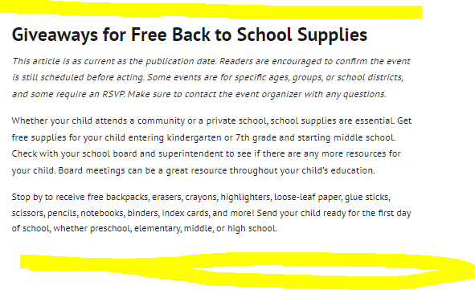

3rd Annual Day of Blessing 2023
Cincinnati Shiloh Seventh-day Adventist Church
3660 Washington Ave, Cincinnati, OH 45229 (Avondale)
July 29
1 p.m.
Receive free school supplies, free haircuts, health screenings, and more. This event is open to all. This event is first-come, first serve and while supplies last. Child must be present with parent to receive supplies.

2nd Annual Community Block Party: Backpacks Giveaway
Kennedy Heights Arts Center Annex
6620 Montgomery Rd Unit 2, Cincinnati, OH 45213 (Kennedy Heights)
August 5
11 a.m. to 3 p.m.
Join Legacy Pointe Church, United Way of Greater Cincinnati, TriHealth and Cincy Smiles for this backpacks giveaway! This event will feature a free bookbag and school supply giveaway, bouncy house, DJ, Kona Ice Truck, Mammography appointments and more!

Back 2 School Carnival
Seasongood Square (Bengals Park)
3801 Reading Rd, Cincinnati, OH 45229 (North Avondale)
August 5
10 a.m. to 2 p.m.
Free backpacks with supplies, limited uniforms, free giveaways, food, games, and music. Children will also receive health and safety education. Parents and children must both be present to receive school supplies; first come, first serve.

Back To School Pop Up Shop
Tryed Stone New Beginning Church
5550 Reading Rd, Cincinnati, OH 45237 (Roselawn)
August 5
11 a.m. to 5 p.m.
78 Business Owners, Food Trucks & Music. We will also be giving away free school supplies for the kids. Come out & have a great time.

Back to School Free Bookbag Giveaway
521 Skincare & Cosmetics
925 Hollytree Dr, Cincinnati, OH 45231 (Finneytown)
August 5
Noon to 5 p.m.
Free bookbags, food, popsicles, and drinks. Your children do not have to be present to receive the giveaways. Get there while supplies last.

Back to School Cuts for Kids
Hunter Park
2047 Dale Rd, Norwood, OH 45212 (Norwood)
August 6
1 p.m.- 6 p.m.
Free haircuts, pizza, backpacks, games, face painting, music, and games. Make sure to reserve a spot for a haircut.

Haircuts for Hope
Empire Beauty School
8419 Colerain Ave, Cincinnati, OH 45239 (Colerain)
August 8
9:30 a.m. to 2:30 p.m. and 6 p.m. to 8 p.m.
Complimentary shampooing, haircuts, and simple styles for children 12 and under. Children will also receive free school supplies. Everything is first come, first serve.

Northside Back To School Community Event
McKie Community Center
1655 Chase Ave, Cincinnati, OH 45223 (Northside)
August 12
1 p.m. to 4 p.m.
Get prepared and excited for the new school year with Guiding Light Mentoring! There will be free school supplies as well as hair braiding and haircuts. There will be games, music, food, and giveaways!

Back To School- School Supplies Giveaway
City on a Hill
5190 Glencrossing Way, Cincinnati 45238 (Covedale)
August 12
1 p.m.
Free backpack and school supplies for kids K-12. You must register for the bag beforehand, and your child must be present to receive the school supplies.

Back 2 School Supply Drive
Hanna Playground
Hanna Playground, 226 Stark St, Cincinnati, OH 45214 (OTR)
August 12
3 p.m. to 6 p.m.
The first 50 kids receive a bookbag and supplies—free haircuts for the entire event.

Back 2 School Uniform Giveaway
Phillips Event Center
1364 Spring Lawn Ave, Cincinnati, OH 45223 (Northside)
August 13
Noon
Free school uniforms size 4 through 16. There will be bouncy houses, food box giveaways, and more. Check your school’s handbook for specifications about uniforms.
Written by: Crystal Kendrick

The Voice of Black Cincinnati is a media company designed to educate, recognize, and create opportunities for African Americans. Want to find local news, events, job posting, scholarships, and a database of local Black-owned businesses? Visit our homepage, explore other articles, subscribe to our newsletter, like our Facebook page, join our Facebook group, and text VOBC to 513-270-3880.

