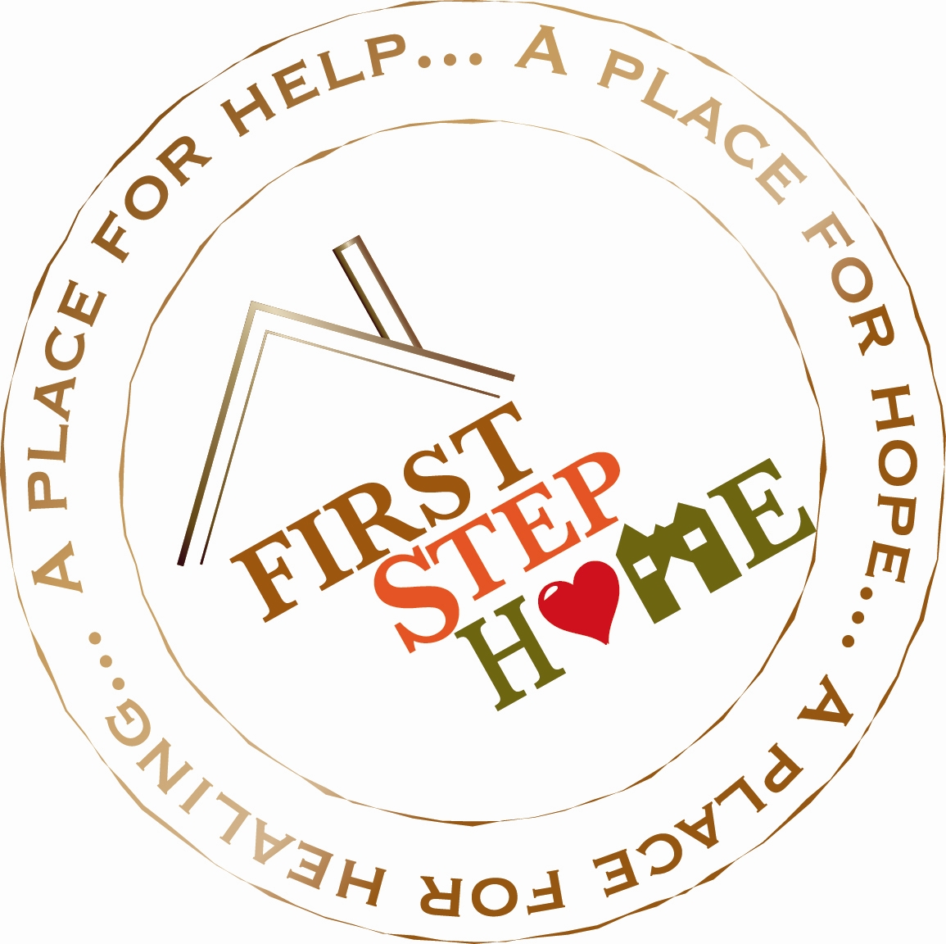

Treatment Phases
During your treatment with FSH, different phases of treatment will be available to you. Level of care is decided on your individual needs and may be different for each women entering treatment. Here at First Step Home, we offer Residential, IOP with supportive housing, and Outpatient treatment services. Each level of care has increased responsibility and privileges designed to help you to grow in your recovery

Residential
This level of care will help you begin to move toward a healthier way of living. Leaving the agency (being on a pass) is limited to medical and legal appointments during this phase of treatment. Treatment occurs seven days a week which includes individual therapy, case management, peer support and group therapy. Length of Residential Treatment is determined on an individual basis according to progress or other situations; however, it often lasts approximately 30 days. Currently due to Covid-19 there will be no family visitation during the residential phase of treatment.

Intensive outpatient with supportive housing (IOP Campus Housing)
This level of care will help you re-enter the community. Privileges may include: walk to store with peers, church, and limited movement in community for medical/legal appointments. Depending on precautionary changes with COVID-19 you may earn increased off-site NA/AA meetings. Vocational services are available to support work towards self-sufficiency. Educational goals can also be developed during this level of care. Treatment occurs five days a week. Length of Campus Intensive Outpatient is determined on an individual basis according to progress and situation; however, it often lasts between 60-180 days.

Outpatient
This level of care will help you stabilize in the community and maintain your sobriety. Each client’s schedule will be determined on an individual basis. Outpatient clients may include clients who are coming from independent housing (off-site) and FSH Recovery Housing.

Your Involvement and Participation
Your participation in setting goals for yourself is an essential part of the program. We will work with you around self sufficiency and developing goals to manage your new drug free life.

*Treatment completion typically takes 1 year

Children
Children are admitted to First Step Home based on bed availability. If a child/children do not enter residential treatment with the client the child/children may then be considered for admission once the client has transitioned to Intensive outpatient with supportive housing, based on bed availability, in Campus Housing. While Covid-19 restrictions are in place children who live at First Step Home cannot leave for the weekends to visit family.

- If there is current children’s services involvement it is the responsibility of the client to contact their children’s services case worker and ask their case worker to contact First Step Home’s children’s services liaison, Jennifer Hoefle (513)961-4663 ext 225. Reunification of the client and their children is sometimes complex and while we support clients being with their children, it is not a guaranteed outcome.

Warrants
If a client has a warrant when entering First Step Home the client is in agreement that the court in the county the warrant is located, will be contacted. The client is also in agreement that the warrant will be resolved during the time at First Step Home.

