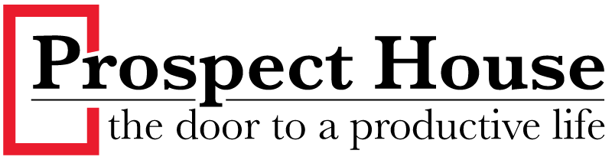

**Mission/Vision:**

Pr0spect House provides abstinence-based long term residential treatment for men experiencing drug and/or alcohol addiction

**Who we serve** adult men who meet the Diagnostic criteria per the DSM-5 for Substance Use Disorder- severe

* Our program was developed to meet the needs of men who are predominately indigent (little to no income or resources)
* Treatment services are designed for those who are post detox and must be able to pass a drug test administered at the time of entry
* Our outreach is focused on Hamilton County residents with some availability for those outside of Hamilton County
* Pr0spective residents must be willing to commit to long term (minimum 6 month) treatment
* Men who have not been convicted of Arson or Sexually oriented crimes

**What we do** to maintain our 74 % success rate is follow the guiding principles of AA as well as Evidenced Based Substance Use Disorder treatment modalities

* Prospect House offers abstinence-based treatment and we do not accept prospective residents that are currently utilizing Medically Assisted Treatment (MAT)
* Residents are required to engage in 12 step activities and follow Prospect House rules
* Consistent engagement in treatment via community based services, individualized one on one counseling, and group therapy
* Support residents in addressing all potential life issues including probation, mental health (via the Health Resource Center), and family concerns



* Offer family support through our Family Prospects program

**How we know it works** is evidenced by our longevity and thriving alumni population

* Prospect House has been a part of the Cincinnati community for over 50 years
* We have a large and involved alumni population that frequently visit and help new residents on the road to recovery
* Our reputation for success allowed us to raise the funds to support our newly developed Family Prospects program to aid in the support of our residents loved ones

**How to enter Prospect House** is through a face-to-face interview with Prospect House Clinical Director Butch England LCDC III

* Located in Price Hill with 45 treatment beds
* Post treatment, many residents take advantage of ¾ housing (15 beds) and alumni housing (19 beds) to stay engaged in the community and continue to work on skill development to be successful in the future
* Funding is a combination of Hamilton County, residents, and donations

**Interested? Reach out to Prospect House via (513) 921-1613 and ask to speak with Butch England**

**Executive Director: John McLellan, Chief Clinical Officer: Samantha Battrell LPCC**

**Associate Executive Director: Butch England LCDC III, Chief Financial Officer: Andy Janssen**