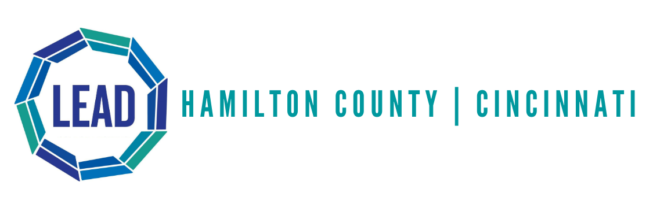

Program Description
The Hamilton County Law Enforcement Assisted Diversion (LEAD) initiative provides direct case management services to individuals impacted by mental health conditions, addiction, and/or chronic homelessness to support their overall stability goals. The focus of the initiative is to divert low-level criminal offenses from the justice system to harm-reduction based services. The LEAD initiative allows police officers to utilize their discretion to divert low-level offenders away from the criminal justice system.

Harm-Reduction Approach

LEAD utilizes a harm-reduction approach. Utilizing this approach not only allows for case managers to focus on reducing the harms of drug and alcohol use on the individual, their families, and the community but also helps focus on the individual’s wellness and quality of life. LEAD staff provides intense harm-reduction based case management services to individuals referred to the program.
Case managers may assist with:
- Connecting individuals to health, mental health, and substance use treatment and other supportive services
- Housing support
- Benefits establishment
- Employment services
- Crisis management

Where to Find Us
The LEAD office is located at 1000 Sycamore St. South Building Room 114 Cincinnati, OH 45202. LEAD staff can be reached by calling 513-946-PLAN (7526). To reach Senior Case Manager, Callie Ward, please call 513-497-1408. To reach the Screening and Outreach Coordinator, Kelsey Richardson, please call 513-497-0356.

