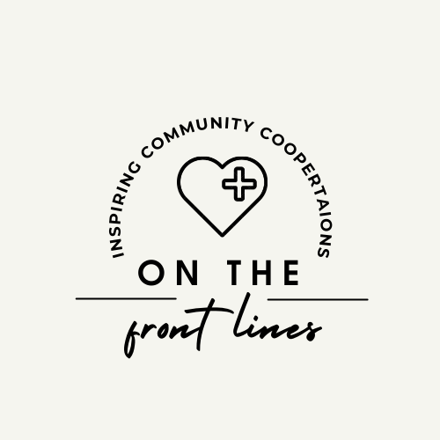

On the Front Lines

September 2, 2021

12:00 pm - 1:30 pm

1. Welcome and Introductions
2. Recent Topics
   1. COVID-19
      * Yes, you heard that right. Get your 1st dose of the COVID-19 vaccine from HCPH and get $100.
      * Locations throughout Hamilton County, find one near you: [HCPH.org/COVID19](http://hcph.org/COVID19?fbclid=IwAR0oruaeyPOFqCTPp44PAGwilY9kz6yugJ6Ao_WBaZAlswM8zcwNk5YOdkg)
      * 
   2. Transitional Respite Program
      * provided by Talbert House
      * For patients that are homeless and have tested positive for Covid 19
        + Provides a safe place for the patient to quarantine
        + 3 meals a day
        + case management. The only requirements for the program are that the patient is both homeless and covid positive
        + provide transportation for the patient from the hospital to the quarantine program.
        + Michael Coppage 513-661-4620, or Whitney Wesner 513-667-2356 We are available Monday through Friday from 8am to 4pm
   3. New Phone Resource
      * FreeStore with Shonda
      * Tuesday & Thursdays 10am-2:30pm
      * Need Valid ID with 1 other document
        + Medical card with DOB
        + Food Stamp Card (works best)
        + Awards Letter
   4. Facilities that take woman with children
      * Transitions
        + Takes Ohio residents
        + Brenda (859) 491-4435
      * First Step Home
        + Ages 12 and younger
        + Must be detoxed
        + <https://www.firststephome.org/pre-screening>
      * Oxford House
        + <https://www.oxfordhouse.org/directory_listing.php>
      * Stepping Stones-Portsmouth
        + Must be detoxed
        + 740-354-6550
      * Xenia Recovery
        + Ages 5 and under
        + <https://www.recoverycentersinc.org/services/>
      * House of Peace-Batavia
        + Clermont, Adams and Brown County residents only
        + 513-753-7281
      * Her Story
        + Xenia, OH
        + (937) 708-8348
        + <https://www.herstoryhouse.com/get-help-now.html>
      * Joshua Recovery
        + Entry into the maternity program begins with Promise To Hope at Miami Valley Hospital. To reach MVH partners directly, please call [937-208-8382](tel:937-208-8382) or [937-208-2481](tel:937-208-2481)
        + <http://www.joshualife.org/maternal-recovery/>
      * Promise to Hope
        + <https://www.mvhfoundation.org/programs-events/promise-to-hope/>
        + **937-208-4093**
   5. Assistance with baby items
      * <https://recoveryconnections.hcph.org/discussion/85/hamilton-county-ohio-equity-institute-resource-guide>
      * Assistance with car seats
        + Community Matters
        + Pregnancy Center
   6. Butler County Resources
      * <https://recoveryconnections.hcph.org/categories/19/surrounding-counties>
   7. Methadone Detox
      * Woodhaven (30mgs or less)
      * CAT (30mgs or less)
      * Ohio Addiction Recovery Center (40mgs or less)
      * Access Hospital (case by case basis)
      * Recovery Works-Columbus (case by case basis)
      * Cedar Oaks (60mgs)
      * CSSL (Dayton)
        + Connie Ames 937-707-2725
        + Can offer ambulatory detox (Bridge device; Speranva) Lucemyra
        + Can stay at residential facility for 2 weeks
        + Up to 120 mgs
      * Midwest Recovery Center (Toledo)
        + (35 mgs or less, case by case basis)
        + 24/7 transportation & admissions (833) 394-6853
   8. Medicare Facilities
      * Genisis-3-month program
      * Georgetown Behavioral-28 day
      * Ridgeview (419) 296-2145
   9. MAT Friendly Recovery Housing
      * New Foundations 513-813-2787
      * Oxford House
      * Recovery Center of Ohio
      * <https://recoveryconnections.hcph.org/discussion/42/interact-for-health-transitional-living-guide>
   10. Obtaining an ID
       * <https://recoveryconnections.hcph.org/discussion/65/page/p1>
       * Brandie Ellery, Social Services Advocate
         + 513-345-1765
         + 1125 Bank Street
         + IDs, BC, SSC, furniture & clothing vouchers
   11. Presumptive Medicaid
       * HealthSource Outreach
         + 513-707-9901
         + Becky McMullen 513-707-4012
   12. 40 Hour Peer Support Trainings
       * EasterSeals
         + 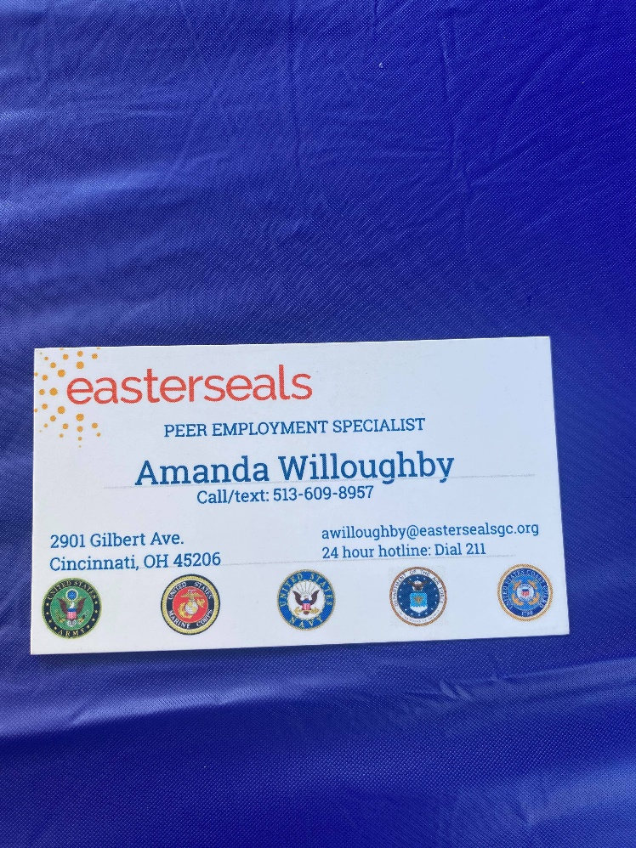
         + <https://mha.ohio.gov/Portals/0/assets/HealthProfessionals/About%20MH%20and%20Addiction%20Treatment/Peer%20Support/PTC/Public-Web-Calendar-PRS-Training-Updated-8.16.21.pdf?ver=TTC6fr9qFFaRvG_qN1dGYg%3d%3d>
   13. Cincinnati Health Network
       * <https://recoveryconnections.hcph.org/discussion/101/cincinnati-health-network>
   14. Narcan for Sober Living Through HCPH
       * Narcan is available for qualified sober living homes
       * It can be used for second hand distribution (giving kits to individual clients who need/want them)
       * It can be used for bringing sober living homes on as service entities (storing the Narcan at their homes in case of an emergency)
       * Paperwork for either option is required for data collection purposes
       * No other requirements at this time
       * Please reach out to Asha Clements at Hamilton County Public Health at [asha.clements@hamilton-co.org](mailto:asha.clements@hamilton-co.org) or call/text 513-309-1522 for FREE kits and FREE Narcan training.
   15. Childrens Counseling
       * A Sound mind counseling 513-948-0023
       * Affinity Center 513-984-1000
       * Beech Acres 513-231-6630
       * Children’s Home of Cincinnati 513-272-2800
       * Cincinnati Children’s Psychiatry 513-636-4124
       * Cincinnati Children’s Hospital Linder Center of Hope 1-888-536-4673
       * Greater Cincinnati Behavioral Health 513-345-8555
   16. Pet Resources

* 1. New Facilities Mentioned
     + Monte B. House
       - Price Hill
       - Men’s Facility
       - Accepts MAT
       - 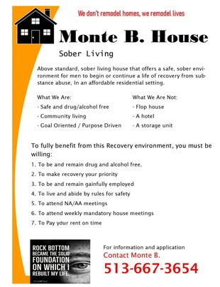
     + Resurge Recovery
       - Open no later than 9/21/21
       - [Timeline

         Description automatically generated with medium confidence](https://bit.ly/ResurgeRecovery)
     + State Line Treatment Services
       - 2 locations
         1. Hamilton (513) 738-7600
         2. Harrison (513) 367-4444
       - IOP, OP, MAT, Family & Individual Counseling
     + Her Story
       - Accepts pregnant woman
       - Accepts MAT
       - Xenia, OH
       - 937-708-8348
       - <https://www.herstoryhouse.com/get-help-now.html>
     + Promise to Hope
       - assists mothers from the initial diagnosis to several months post-partum
       - goal of keeping mother and child together in a stable home environment
       - <https://www.mvhfoundation.org/programs-events/promise-to-hope/>
       - **937-208-4093**
     + Ethan’s Crossing
       - MAT Detox, Residential (men’s and woman’s), PHP, IOP, OP, Aftercare
         1. Springfield
       - <https://www.ethancrossingspringfield.com/springfield-ohio-addiction-treatment-center-programs/>
       - [(833) 691-0736](https://www.google.com/search?gs_ssp=eJzj4tVP1zc0zDI2SSnMqDI2YLRSNaiwsDBOM01KMzA0sbRISjJPszKoSE4xTLZMTUwxSk5KM0lOSvISSC3JSMxTL1ZILsovLs7MSwcA-ggWgw&q=ethan%27s+crossing&rlz=1C1GCEA_enUS909US909&oq=ethans+&aqs=chrome.1.69i57j46i10i175i199i512j0i10i512l5j0i512j0i10i512.2958j0j4&sourceid=chrome&ie=UTF-8)
     + Eagle Creek
       - stabilization, residential treatment services, internship programs and career opportunities for women with SUD
       - (606) 638-0938 (intake)
       - Owenton KY
     + The Orient
       - 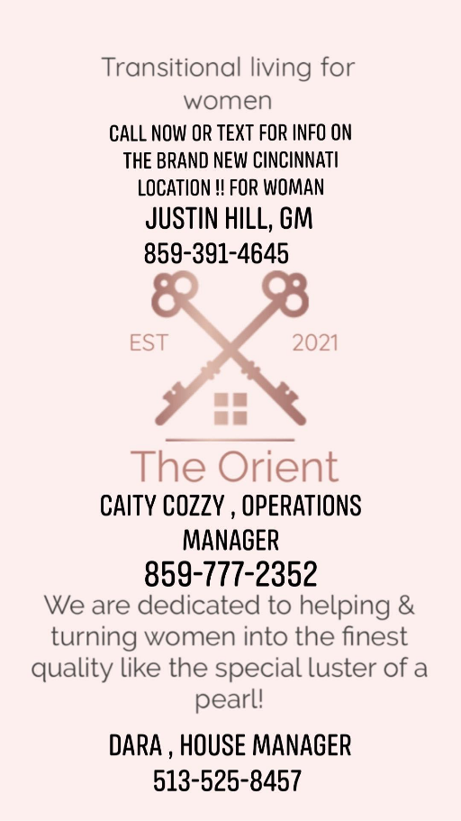
     + New SSP Van
       - <https://www.facebook.com/hc.xchange/posts/830411867587648>
     + CRN Healthcare
       - OP facility with sober living

Medicaid pays for Housing

* + - * 513-904-9313
    - Hope Valley Recovery Center
      * Brad Durkin
      * 614-746-9937

**Community Linking Stations | Weekly Schedule**

**_____________________________________________________________________________________________**

|  |  |  |
| --- | --- | --- |
| **Tuesdays**  East Price Hill |  | **Weightless Anchor**  **1 p.m. to 4 p.m.**  962 Mansion Ave  Cincinnati, OH 45205   * Harm Reduction resources & supplies * Linkage to treatment and recovery services * Free HIV & Hep C testing through UC Health   **serving only Weightless Anchor clients |
| **Wednesdays**  East Price Hill |  | **BLOC Church**  **11 a.m. to 2 p.m.**  931 McPherson Ave  Cincinnati, OH 45205   * Linkage to treatment and recovery services * Connections to social services * Peer support connections |
| **Thursdays**  Lower Price Hill |  | **Community Matters**  **12 p.m. to 2 p.m.**  2104 St. Michaels St  Cincinnati, OH 45204   * Harm Reduction resources & supplies * Linkage to treatment and recovery services * Connections to social services * Peer support connections |
|  |  |  |

**Additional Resources**:

Project Contact: Hannah Schilling (513) 999-3866

The Exchange Project Weekly Schedule-text Location to #22999

Narcan Distribution Service – text Narcan to #22999

* 1. Job Postings
     + Lumiere
       - 1st shift CDCA position
       - Joan Burger-Holt 513-646-5003
     + Total Source
       - Chapter Lead
       - Working with young people in recovery
       - [https://www.ziprecruiter.com/c/YOUNG-PEOPLE-IN-RECOVERY-TOTALSOURCE/Job/Chapter-Lead/-in-Cincinnati,OH?jid=3d726cc32995b5c7](https://www.ziprecruiter.com/c/YOUNG-PEOPLE-IN-RECOVERY-TOTALSOURCE/Job/Chapter-Lead/-in-Cincinnati,OH?jid=3d726cc32995b5c7&fbclid=IwAR24PukXeOxVRzET5LWwIHMcy4U6XXCT3Y0nDY41X5_dyu5gzdCbKgIQ5as)
     + Hamilton County Public Health
       - Health Counselor
       - Manage new project through Ohio Means Jobs
     + [https://www.hamiltoncountyhealth.org/about-us/employment/](https://www.hamiltoncountyhealth.org/about-us/employment/?fbclid=IwAR2xDPdkd98LcIY6barHl-BAmCP_JGPix-_7iAGsXY2n76CBt3Lz1it9D20)

1. Key Note
   1. Sun Behavioral
2. Currents barriers/concerns
3. Future Meeting Presenters/Topics
4. Questions/Discussion
   1. <https://recoveryconnections.hcph.org/discussions>
      * Forum for recovery professionals to share resources and network
5. Upcoming Meetings