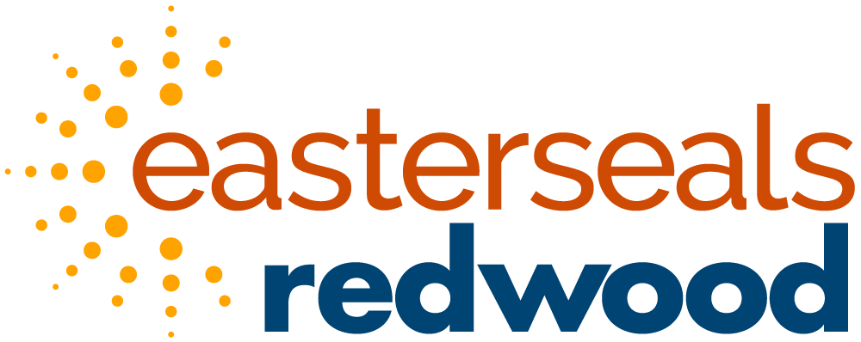
Peer Services Programs Open House
PREP and Project POWER invite you to come see what amazing things we have to offer. Enjoy a light lunch, take a tour, meet the staff, as well as current and former participants.
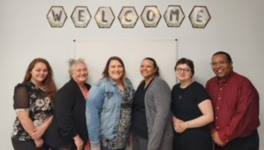
Date: June 12, 2023 Time: 11am-2pm
Ohio Means Jobs Room C
1916 Central Pkwy
Cincinnati, OH 45214
There will be a panel discussion between 12-1 with current and former participants to share their experience.
Please register by June 9, 2023 @ https://www.eventbrite.com/e/easterseals-redwood-recovery-open-house-tickets-625557628707?utm-campaign=social&utm-content=attendeeshare&utm-medium=discovery&utm-term=listing&utm-source=cp&aff=escb

